Caeser cipher
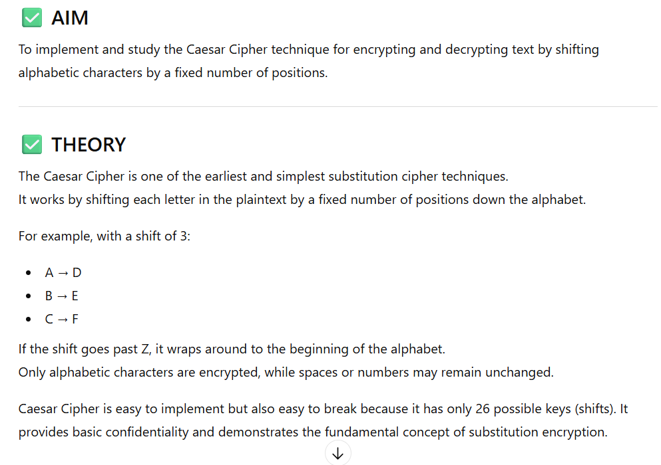
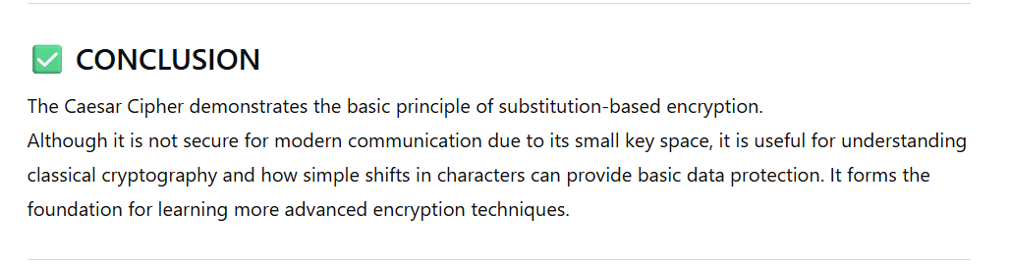

1) def caesar_cipher(text, shift):
result = ""

for char in text:
if char.isalpha(): # Check if alphabet
base = ord('A') if char.isupper() else ord('a')
# Shift character
result += chr((ord(char) - base + shift) % 26 + base)
else:
result += char # Non-letters remain same

return result

# ---- User Input ----
text = input("Enter text: ")
shift = int(input("Enter shift value: "))

encrypted = caesar_cipher(text, shift)
print("Encrypted text:", encrypted)

Monoalphabetic cipher

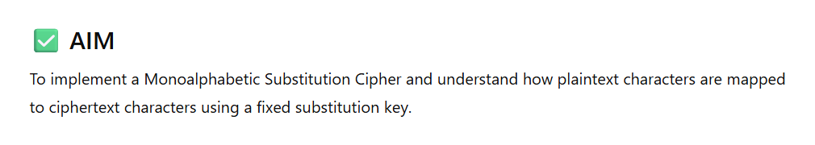
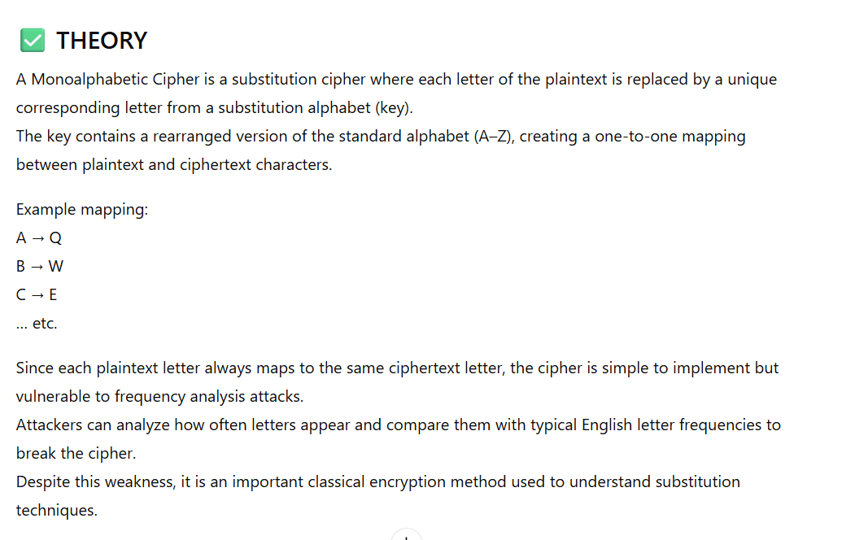
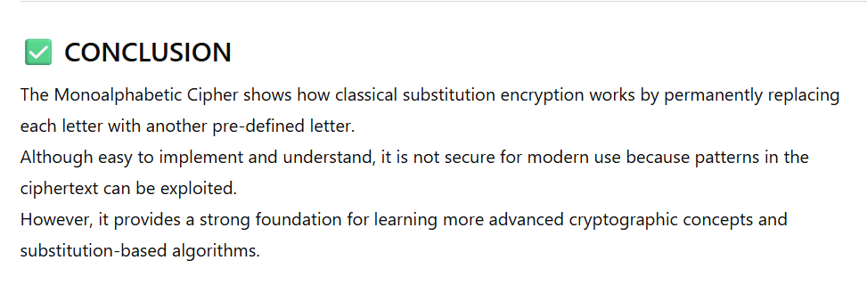

2) def monoalphabetic_encrypt(text, key):
text = text.upper()
result = ""
alphabet = "ABCDEFGHIJKLMNOPQRSTUVWXYZ"

for char in text:
if char.isalpha():
index = alphabet.index(char)
result += key[index]
else:
result += char
return result

# ------- USER INPUT -------
plaintext = input("Enter text: ")
key = "QWERTYUIOPASDFGHJKLZXCVBNM".upper()

# Example key: QWERTYUIOPASDFGHJKLZXCVBNM

ciphertext = monoalphabetic_encrypt(plaintext, key)
print("Encrypted text:", ciphertext)

Railfence cipher


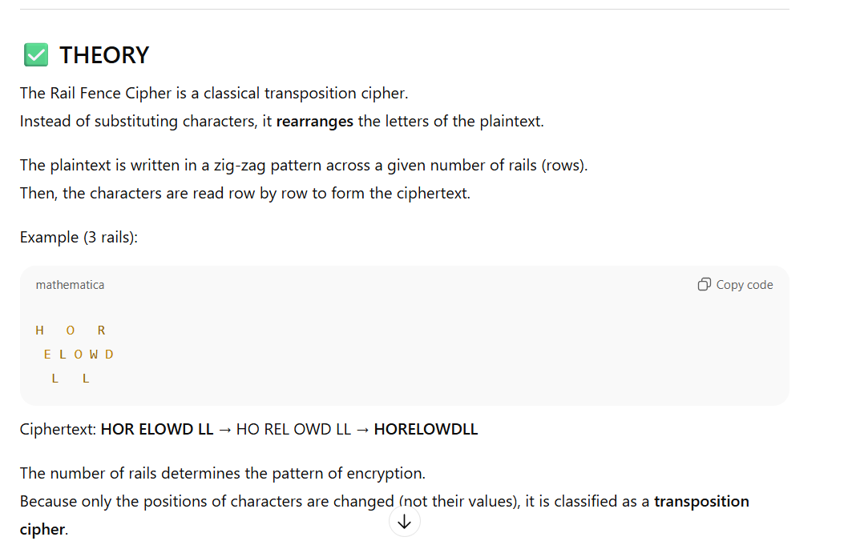
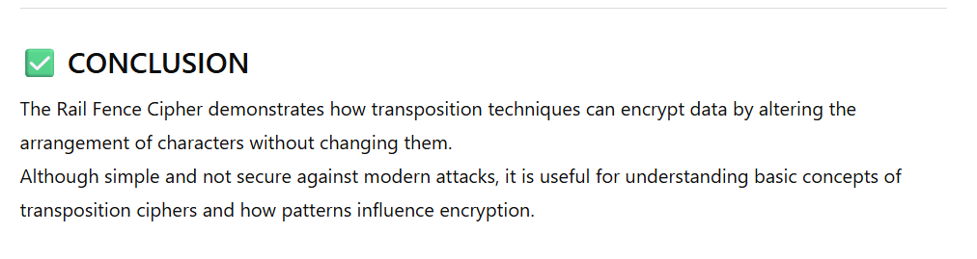

3) def rail_fence_encrypt(text, rails):
# Create a list of empty strings for each rail
fence = [''] * rails
row = 0
direction = 1 # 1 = moving down, -1 = moving up

for char in text:
fence[row] += char

# Change direction at the top or bottom rail
if row == 0:
direction = 1
elif row == rails - 1:
direction = -1

row += direction

# Join all rails to get ciphertext
return ''.join(fence)

# ---------- USER INPUT ----------
text = input("Enter text: ")
rails = int(input("Enter number of rails: "))

cipher = rail_fence_encrypt(text, rails)
print("Encrypted text:", cipher)

Diffie hellman

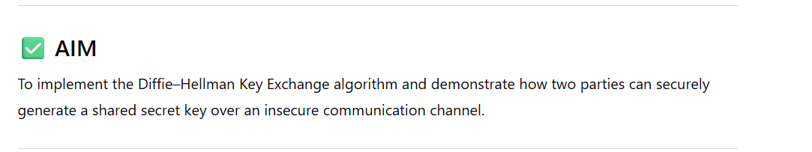
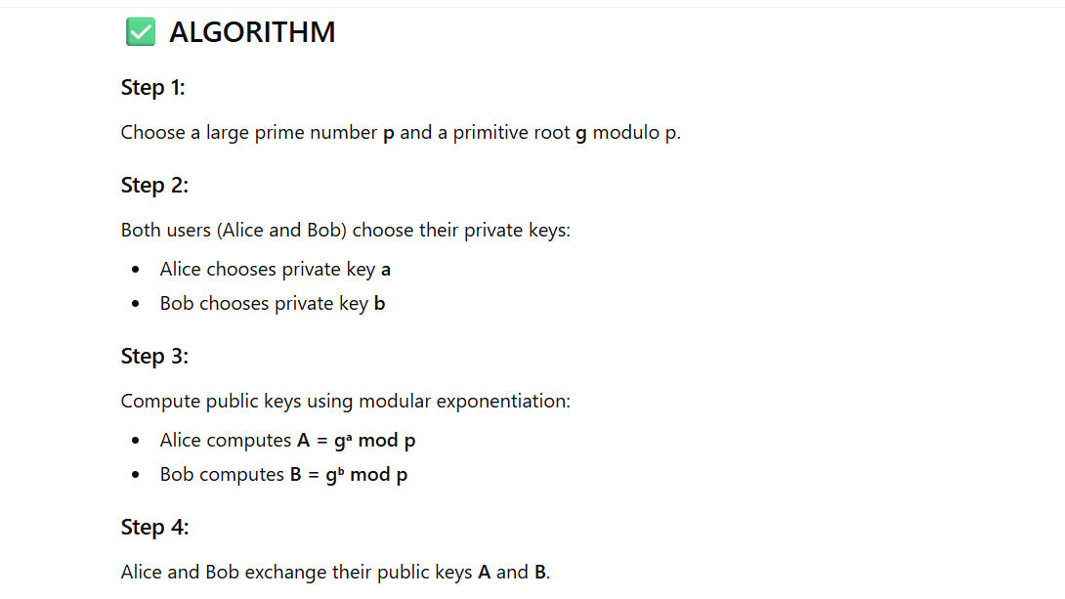
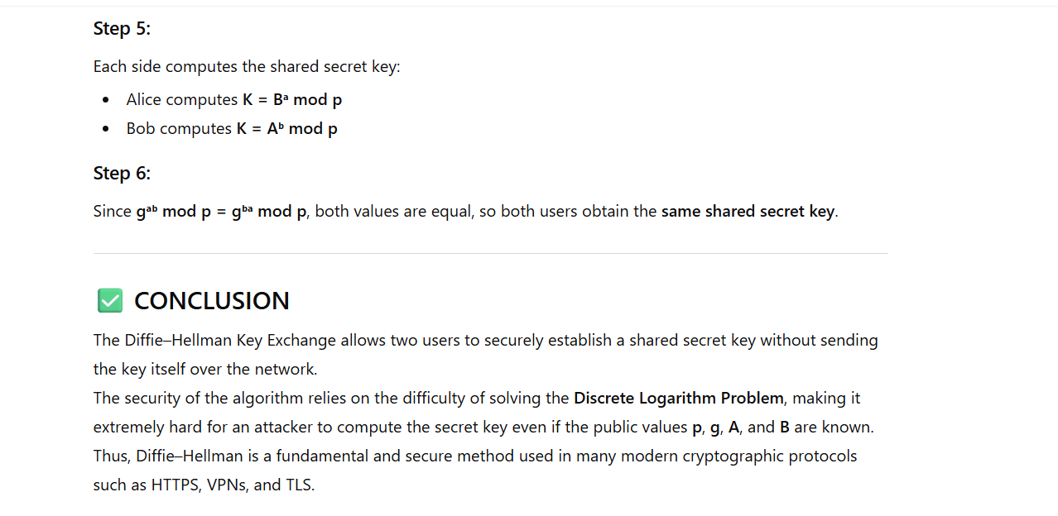

4) def is_prime(n):
"""Check if a number is prime."""
if n < 2:
return False
for i in range(2, int(n ** 0.5) + 1):
if n % i == 0:
return False
return True

def prime_factors(n):
"""Return the set of prime factors of n."""
factors = set()
i = 2
while i * i <= n:
while n % i == 0:
factors.add(i)
n //= i
i += 1
if n > 1:
factors.add(n)
return factors

def is_primitive_root(g, p):
"""Check if g is a primitive root modulo p."""
phi = p - 1
factors = prime_factors(phi)
for factor in factors:
if pow(g, phi // factor, p) == 1:
return False
return True

def find_primitive_roots(p):
"""Find all primitive roots for prime p."""
return [g for g in range(2, p) if is_primitive_root(g, p)]

def diffie_hellman():
p = int(input("Enter a prime number p: "))

if not is_prime(p):
print("❌ Error: p is not a prime number!")
return

print("\n🔍 Finding primitive roots of", p, "...\n")
roots = find_primitive_roots(p)

if not roots:
print("❌ No primitive roots found! (Very rare case)")
return

print("✅ Primitive Roots of", p, ":", roots)

g = int(input("\nChoose any primitive root g from the above list: "))
if g not in roots:
print("❌ Invalid choice! g must be a primitive root.")
return

# Private keys
a = int(input("Enter Alice's private key (a): "))
b = int(input("Enter Bob's private key (b): "))

# Public keys
A = pow(g, a, p)
B = pow(g, b, p)

print("\n🔑 Public Keys:")
print("Alice sends A =", A)
print("Bob sends B =", B)

# Shared secrets
secret_A = pow(B, a, p)
secret_B = pow(A, b, p)

print("\n🔐 Shared Secrets:")
print("Alice computes:", secret_A)
print("Bob computes: ", secret_B)

if secret_A == secret_B:
print("\n🎉 Key Exchange Successful! Shared Secret Key =", secret_A)
else:
print("\n❌ Key Mismatch! Something went wrong!")

# Run the program
diffie_hellman()

RSA

5) import math

# Function to check if a number is prime
def is_prime(num):
if num <= 1:
return False
for i in range(2, int(math.sqrt(num)) + 1):
if num % i == 0:
return False
return True

# Function to compute gcd
def gcd(a, b):
while b != 0:
a, b = b, a % b
return a

# Updated modular inverse function: prints 5 equivalent values
def mod_inverse(e, phi):
for d in range(2, phi):
if (d * e) % phi == 1:
print("Possible values of d:")
for k in range(5):
print(d + k * phi, end=" ")
print()
return d # return the base modular inverse
print("No modular inverse found")
return None

# RSA Implementation
def rsa_program():
# Step 1: Read two numbers
p = int(input("Enter first prime number (p): "))
q = int(input("Enter second prime number (q): "))

# Step 2: Check if prime
if not is_prime(p) or not is_prime(q):
print("Error: Both numbers must be prime.")
return

# Step 3: Check if same
if p == q:
print("Error: p and q cannot be the same.")
return

# Step 4: Compute n and phi
n = p * q
phi = (p - 1) * (q - 1)

# Step 5: Choose e (1 < e < phi, gcd(e, phi) = 1)
e = 2
while e < phi:
if gcd(e, phi) == 1:
break
e += 1

# Step 6: Compute d (modular inverse of e mod phi)
d = mod_inverse(e, phi)

if d is None:
print("Cannot find modular inverse. Exiting...")
return

print("\nRSA Key Generation Successful!")
print("Public Key (e, n): (", e, ",", n, ")")
print("Private Key (d, n): (", d, ",", n, ")")

# Step 7: Encryption and Decryption
message = int(input("\nEnter a number to encrypt (as integer): "))

# Check if message is less than n
if message >= n:
print("Error: Message must be less than n.")
return

encrypted = pow(message, e, n) # C = M^e mod n
decrypted = pow(encrypted, d, n) # M = C^d mod n

print("Original Message:", message)
print("Encrypted Message:", encrypted)
print("Decrypted Message:", decrypted)

# Run Program
rsa_program()

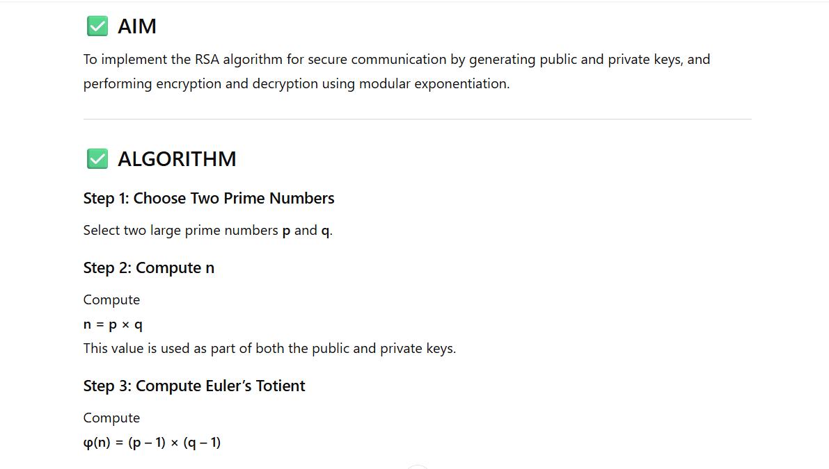
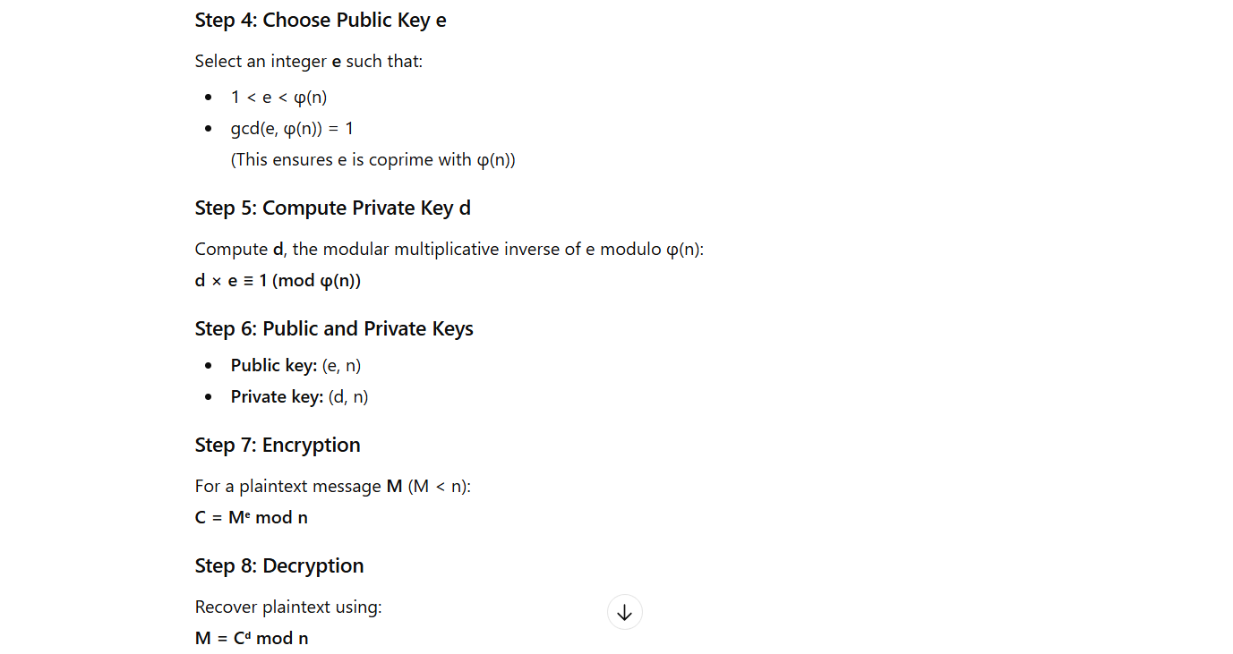
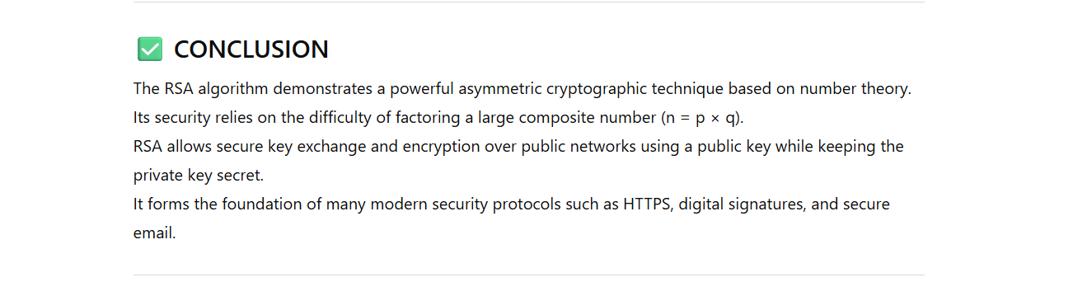

ELGAMAL
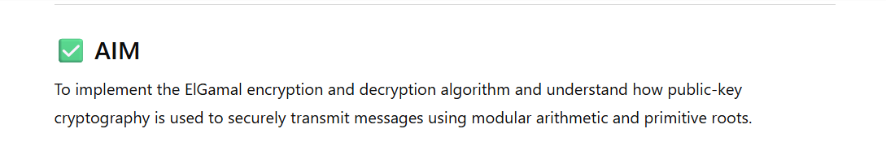
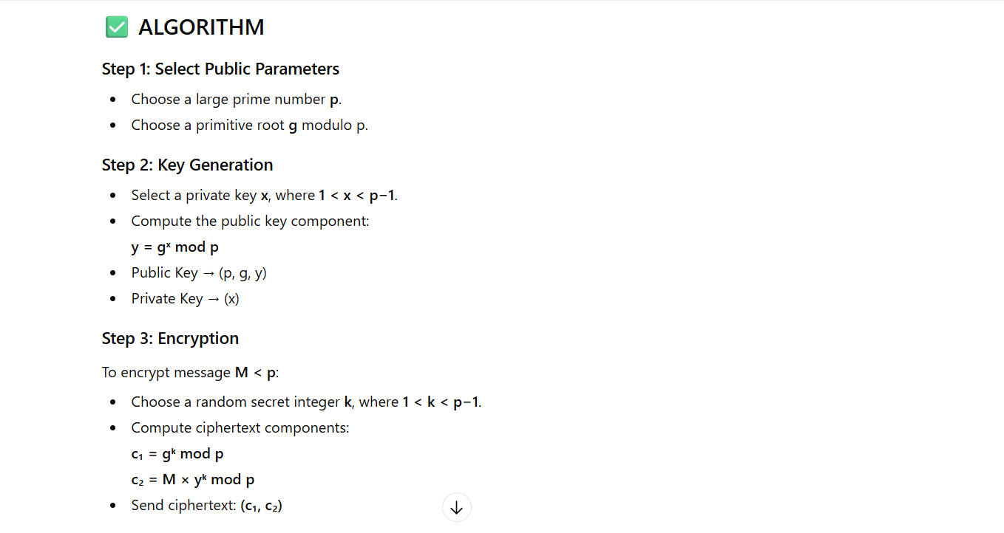
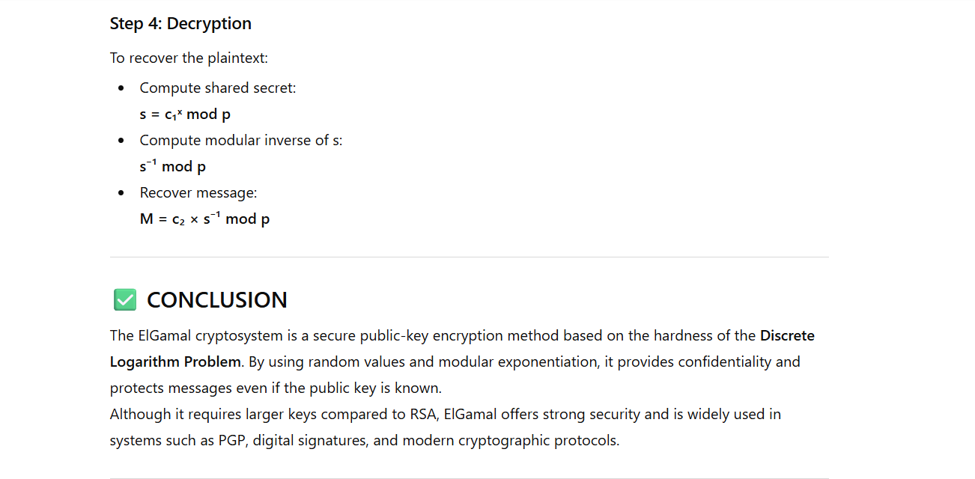

6) # Simple ElGamal with user input for p, g, and x
import math

# Check if a number is prime
def is_prime(n):
if n <= 1:
return False
for i in range(2, int(math.sqrt(n)) + 1):
if n % i == 0:
return False
return True

# Find primitive roots of p
def primitive_roots(p):
roots = []
for g in range(2, p):
powers = set()
for k in range(1, p):
powers.add(pow(g, k, p))
if len(powers) == p - 1: # primitive root condition
roots.append(g)
return roots

# Modular exponentiation
def mod_exp(base, exp, mod):
return pow(base, exp, mod)

# Generate public key y
def generate_keys(p, g, x):
y = mod_exp(g, x, p) # y = g^x mod p
return y

# Encrypt message
def encrypt(p, g, y, message, k):
c1 = mod_exp(g, k, p)
c2 = (message * mod_exp(y, k, p)) % p
return c1, c2

# Decrypt message
def decrypt(p, x, c1, c2):
s = mod_exp(c1, x, p)
s_inv = pow(s, -1, p)
message = (c2 * s_inv) % p
return message

# ---------------- MAIN PROGRAM ----------------

# User input for p
p = int(input("Enter a prime number p: "))

if not is_prime(p):
print("Error: p must be a prime number.")
exit()

# Show all possible primitive roots of p
roots = primitive_roots(p)
print("Possible primitive roots (g) for p are:", roots)

# User selects g
g = int(input("Choose a primitive root g from the list: "))

if g not in roots:
print("Error: g is not a primitive root of p.")
exit()

# User inputs private key
x = int(input("Enter private key x (1 < x < p-1): "))

if x <= 1 or x >= p - 1:
print("Error: Invalid private key.")
exit()

# Generate y
y = generate_keys(p, g, x)

print("\n--- ElGamal Keys ---")
print("Public Key (p, g, y):", p, g, y)
print("Private Key x:", x)

# Message input
message = int(input("\nEnter a message (number < p): "))

if message >= p:
print("Error: Message must be less than p.")
exit()

# Random k (for simplicity, user enters k)
k = int(input("Enter random secret k (1 < k < p-1): "))

if k <= 1 or k >= p - 1:
print("Error: Invalid k.")
exit()

# Encryption
c1, c2 = encrypt(p, g, y, message, k)
print("\nEncrypted Ciphertext (c1, c2):", c1, c2)

# Decryption
decrypted = decrypt(p, x, c1, c2)
print("Decrypted Message:", decrypted)

HILL cipher

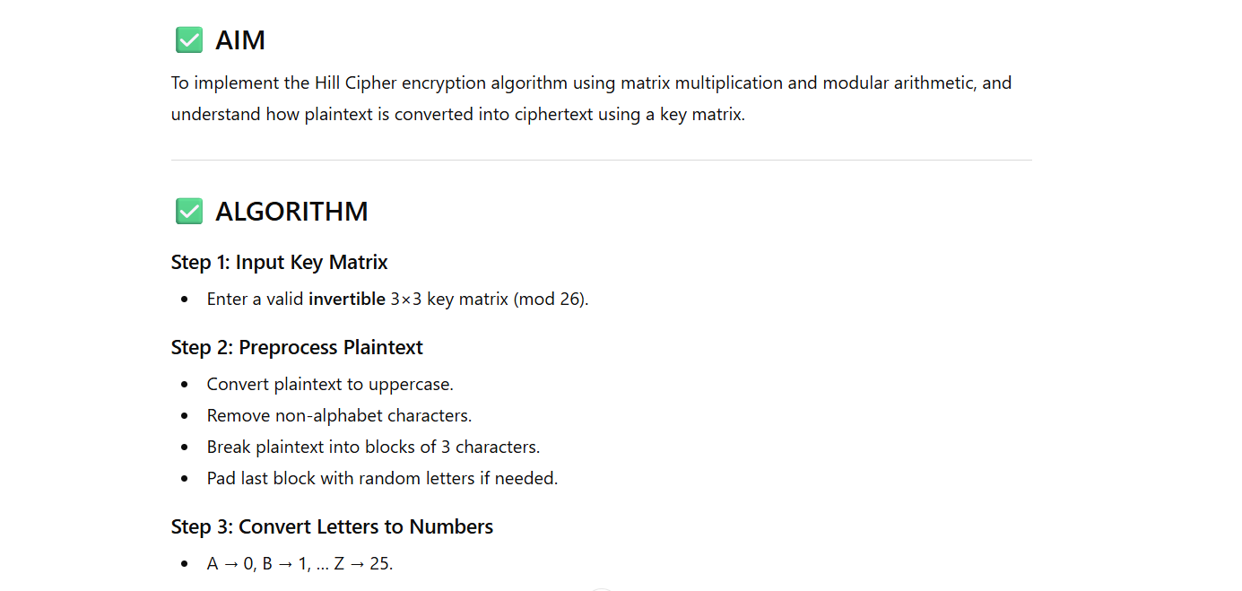
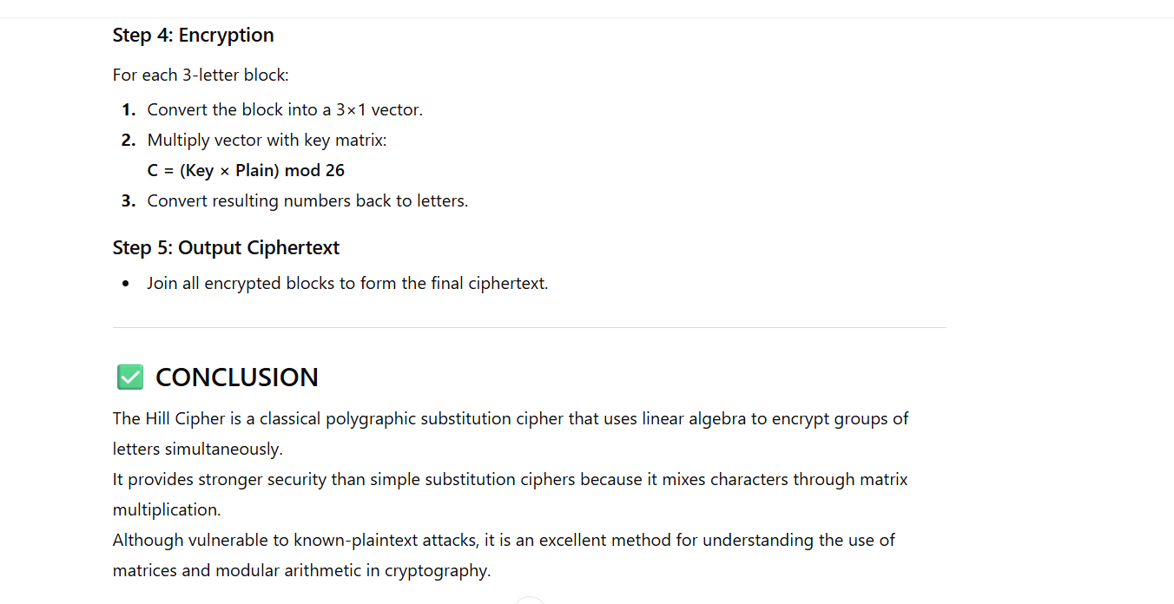

import numpy as np
import random
import string

# ----------------------------------------------------
# Step 1: Read 3×3 Key Matrix
# ----------------------------------------------------
print("Enter the 3×3 key matrix (row by row, space separated):")

key_matrix = []
for i in range(3):
row = list(map(int, input(f"Row {i+1}: ").split()))
if len(row) != 3:
raise ValueError("Each row must contain exactly 3 integers.")
key_matrix.append(row)

key_matrix = np.array(key_matrix)
print("\nKey Matrix:")
print(key_matrix)

# ----------------------------------------------------
# Helper Functions
# ----------------------------------------------------
def text_to_numbers(text):
"""Convert letters A–Z → numbers 0–25."""
return [ord(c) - ord('A') for c in text]

def numbers_to_text(nums):
"""Convert numbers 0–25 → letters A–Z."""
return ''.join(chr(n % 26 + ord('A')) for n in nums)

def mod_inverse(a, m):
"""Find modular inverse of a under mod m."""
a = a % m
for x in range(1, m):
if (a * x) % m == 1:
return x
return None

def matrix_mod_inverse(matrix, modulus):
"""Compute modular inverse of a 3×3 matrix under mod 26."""
det = int(round(np.linalg.det(matrix))) % modulus
inv_det = mod_inverse(det, modulus)

if inv_det is None:
raise ValueError(f"Matrix is not invertible under mod {modulus}")

# adj(A) = round(det * inv(A))
adj = np.round(det * np.linalg.inv(matrix)).astype(int) % modulus
return (inv_det * adj) % modulus

# ----------------------------------------------------
# Step 2: Read Plaintext
# ----------------------------------------------------
plaintext = input("\nEnter plaintext: ").upper()
plaintext = ''.join(c for c in plaintext if c.isalpha())

print("Processed Plaintext:", plaintext)

# ----------------------------------------------------
# Step 3: Break into groups of 3
# ----------------------------------------------------
groups = [plaintext[i:i + 3] for i in range(0, len(plaintext), 3)]

# ----------------------------------------------------
# Step 4: Pad last block if needed
# ----------------------------------------------------
if len(groups[-1]) < 3:
needed = 3 - len(groups[-1])
padding = ''.join(random.choice(string.ascii_uppercase) for _ in range(needed))
groups[-1] += padding

print("\nPlaintext groups (with padding if needed):")
print(groups)

# ----------------------------------------------------
# Step 5: Encrypt
# ----------------------------------------------------
ciphertext = ""

for group in groups:
block = np.array(text_to_numbers(group)).reshape(3, 1)
encrypted_block = np.dot(key_matrix, block) % 26
ciphertext += numbers_to_text(encrypted_block.flatten())

print("\nCiphertext:", ciphertext)

Playfair cipher
import string

def generate_key_matrix(key):
key = key.upper().replace("J", "I")
used = set()
matrix = []

# Add key letters
for ch in key:
if ch.isalpha() and ch not in used:
used.add(ch)
matrix.append(ch)

# Add remaining alphabet letters
for ch in string.ascii_uppercase:
if ch == "J":
continue
if ch not in used:
used.add(ch)
matrix.append(ch)

# Convert to 5×5 matrix
matrix = [matrix[i:i+5] for i in range(0, 25, 5)]
return matrix

def find_pos(matrix, ch):
for i in range(5):
for j in range(5):
if matrix[i][j] == ch:
return i, j
return None

def prepare_text(text):
text = text.upper().replace("J", "I")
text = ''.join(ch for ch in text if ch.isalpha())

prepared = ""
i = 0
while i < len(text):
a = text[i]
b = text[i+1] if i+1 < len(text) else "X"

if a == b:
prepared += a + "X"
i += 1
else:
prepared += a + b
i += 2

if len(prepared) % 2 != 0:
prepared += "X"

return prepared

def encrypt(text, matrix):
cipher = ""
for i in range(0, len(text), 2):
a, b = text[i], text[i+1]
r1, c1 = find_pos(matrix, a)
r2, c2 = find_pos(matrix, b)

if r1 == r2: # same row
cipher += matrix[r1][(c1 + 1) % 5]
cipher += matrix[r2][(c2 + 1) % 5]

elif c1 == c2: # same column
cipher += matrix[(r1 + 1) % 5][c1]
cipher += matrix[(r2 + 1) % 5][c2]

else: # rectangle rule
cipher += matrix[r1][c2]
cipher += matrix[r2][c1]

return cipher

def decrypt(cipher, matrix):
plain = ""
for i in range(0, len(cipher), 2):
a, b = cipher[i], cipher[i+1]
r1, c1 = find_pos(matrix, a)
r2, c2 = find_pos(matrix, b)

if r1 == r2: # same row
plain += matrix[r1][(c1 - 1) % 5]
plain += matrix[r2][(c2 - 1) % 5]

elif c1 == c2: # same column
plain += matrix[(r1 - 1) % 5][c1]
plain += matrix[(r2 - 1) % 5][c2]

else:
plain += matrix[r1][c2]
plain += matrix[r2][c1]

return plain

# ----------------------------------------------------

key = input("Enter key: ")
matrix = generate_key_matrix(key)

print("\nPlayfair Matrix:")
for row in matrix:
print(row)

plaintext = input("\nEnter plaintext: ")
prepared = prepare_text(plaintext)
print("Prepared text:", prepared)

cipher = encrypt(prepared, matrix)
print("Ciphertext:", cipher)

plain = decrypt(cipher, matrix)
print("Decrypted text:", plain)
